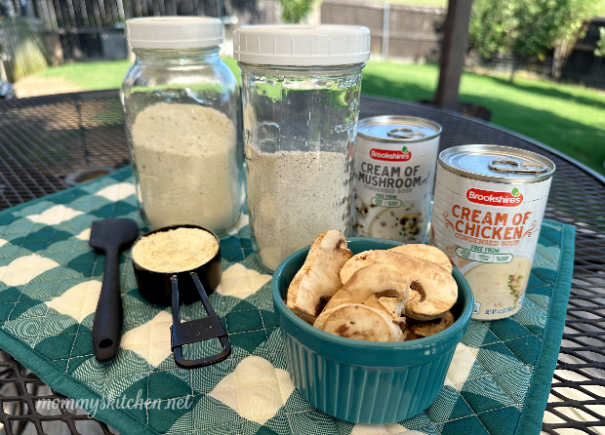
Cream of Soup Mix Base
Create your own Cream of soup base to have on hand for quick, easy casseroles, cream sauces and more. This versatile recipe can easily be adapted to fit any recipe requiring a can of “cream of mushroom or chicken soup.
Prep time: 15 MinCook time: 7 MinTotal time: 22 Min
Ingredients
Cream of Chicken Soup Mix
- 2 - cups powdered milk
- 3/4 - cup cornstarch
- 1/4 - cup chicken bouillon
- 1/2 - teaspoon pepper
- 1 - teaspoon parsley
- 1/2 - teaspoon thyme
- 1 - teaspoon garlic powder
- 1 - teaspoon onion powder
Cream of Mushroom Soup MIx
- 2 - cups powdered milk
- 3/4 - cup cornstarch
- 1/2 - cup dehydrated mushrooms, crushed
- 1/2 - teaspoon pepper
- 1 - teaspoon parsley
- 1/2 - teaspoon thyme
- 1 - teaspoon garlic powder
- 1 - teaspoon onion powder
Instructions
- Mix all the dry ingredients together, and store in a quart size mason jar until ready to use.
- To make 1 can of cream of chicken soup, melt 1 tablespoons of butter in a small pot.
- Add 1/3 cup of your soup mix base and heat for 1 minute.
- Mix in 1 cup of cold water. Whisk well, and bring to a boil.
- Lower the heat a to a simmer and cook until mixture thicken (about 5-7 minutes) Stirring frequently.
- Remove from heat, and allow the mixture to cool for 3-5 minutes.
- Use in any recipe that calls for one can of cream of chicken soup or mushroom soup.
The New "Cream of Shrimp" Mix
Keep your powdered milk and cornstarch measurements the same, but update your spices to this layout:
- 2 cups Powdered Milk
- ¾ cup Cornstarch
- 4 crumbled Knorr Shrimp Bouillon Cubes (Your ¼ cup equivalent)
- 1 teaspoon Garlic Powder
- 1 teaspoon Onion Powder
- ½ teaspoon Black Pepper
- 1 teaspoon Old Bay Seasoning (or any Cajun/seafood seasoning)
- ½ teaspoon Dried Dill Weed (replaces the thyme)
- ¼ teaspoon Paprika (adds a beautiful light pink tint to the shrimp cream)
How to Cook and Use It
When you are ready to make a meal out of your dry mix, use it exactly like a commercial can of condensed cream soup:
- The Base: Whisk ⅓ cup of your dry mix into 1 cup of cold water or whole milk in a saucepan.
- Thicken: Cook over medium heat, stirring constantly, until it bubbles and gets thick and glossy.
- The Shrimp Add-in: Toss in some small salad shrimp, diced celery, or even a little bit of butter. Let the shrimp warm through right in the hot soup before serving.

Notes
Shelf life for non fat powdered milk is 1 year. Full fat powdered milk is 6 months.



